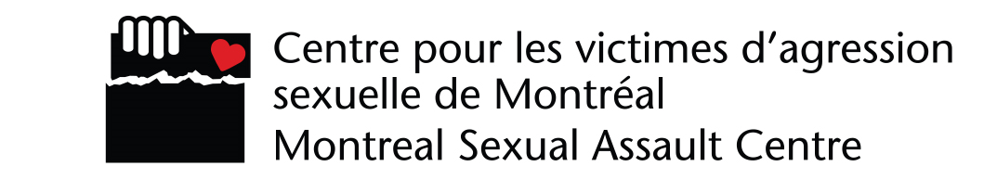
COMPLAINT FORM

Please use the form below to describe and submit your complaint regarding a service or services provided by the Montreal Sexual Assault Centre.
Email your completed form as an attached file to plaintes@cvasm.ca, indicating “Direction-complaint-confidential” on the email subject line.

Complainant Information

Your information will be kept strictly confidential and will be used only to follow up your complaint.
First name
Last name
Address (street name and number, apartment)
City
Province |  |  |  |  | Postal code
Telephone
Email
If you have a preferred method of communication (telephone, for example), please indicate it here:

Subject of the complaint
Put an “X” in the box next to the service(s) concerned by the complaint.
 |  | Medico-social intervention
 |  | Individual counselling
 |  | Sexual Violence Helpline
Please clearly describe the reason for your complaint, indicating date(s), location(s), circumstances, etc.
Date:
Type in your name as your signature:

